Línur og plön
Win 1500000 SMLY if you ace this lecture, bonus 2000000 SMLY for acing whole tutorial

A plane contains the point (1,2,3) and has the normal vector n=(2,2,4)'.
The equation of the plane can be written:
- 2x+2y+4z=18
- 2x+2y+4z=12
- 2x+2y+z=18
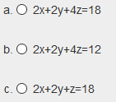
Svar: a

A plane is spanned by the vectors u=(2,0,2)' and v=(1,1,1)'.
Which of the following vectors can be use as a normal vector for the plane?
- (-1,1,1)'
- (-1,0,1)'
- (-1,1,0)'
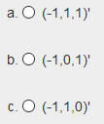
Svar: b
A plane is spanned by the vectors u=(2,0,2)' and v=(1,2,1)'.
Which of the following vectors can be use as a normal vector for the plane?
- (-2,1,0)'
- (-3,1,3)'
- (-3,0,3)'
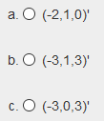
Svar: c

A plane is spanned by the vectors u=(2,0,2)' and v=(1,1,1)'.
Which of the following vectors can be use as a normal vector for the plane?
- (-1,1,0)'
- (-3,0,3)'
- (-3,1,3)'
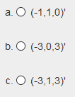
Svar: b
A plane is spanned by the vectors u=(2,0,2)' and v=(1,3,1)'.
Which of the following vectors can be use as a normal vector for the plane?
- (-3,1,3)'
- (-3,1,0)'
- (-3,0,3)'
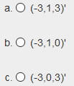
Svar: c

A plane is spanned by the vectors u=(2,0,2)' and v=(1,1,1)'.
Which of the following vectors can be use as a normal vector for the plane?
- (-2,0,2)'
- (-1,1,0)'
- (-2,1,2)'
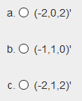
Svar: a
A plane is spanned by the vectors u=(2,0,2)' and v=(1,3,1)'.
Which of the following vectors can be use as a normal vector for the plane?
- (-1,1,1)'
- (-3,1,0)'
- (-1,0,1)'
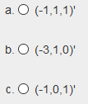
Svar: c

A plane contains the point (1,2,3) and has the normal vector n=(2,2,6)'.
The equation of the plane can be written: 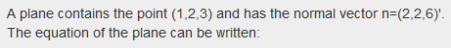
- 2x+2y+6z=18
- 2x+2y+6z=24
- 2x+2y+z=24
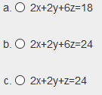
Svar: b
Gefin er jafna plans í R3: x+y−z=2
Hvern eftirfarandi vigra má nota sem normalvigur plansins? 
- ( 1, 1,-1)'
- ( 1, 1, 1)'
- ( 1, 1, 2)'
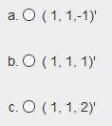
Svar: a

A plane is spanned by the vectors u=(2,0,2)' and v=(1,2,1)'.
Which of the following vectors can be use as a normal vector for the plane?
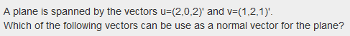
- (-2,0,2)'
- (-2,1,2)'
- (-2,1,0)'
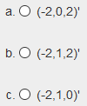
Svar: a

Gefin er jafna plans í R3: 2x+y−z=5
Eru punktarnir P=(1,2,1) og Q=(1,1,2) í planinu?

- bara Q
- bara P
- hvorki P né Q
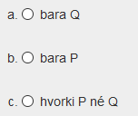
Svar: c

A plane is spanned by the vectors u=(2,0,2)' and v=(1,3,1)'.
Which of the following vectors can be use as a normal vector for the plane? 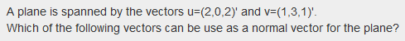
- (-2,0,2)'
- (-2,1,2)'
- (-3,1,0)'
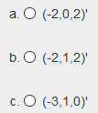
Svar: a
A plane contains the point (1,2,3) and has the normal vector n=(2,2,2)'.
The equation of the plane can be written:
- 2x+2y+2z=6
- 2x+2y+2z=12
- 2x+2y+z=12
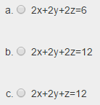
Svar: b

Gefin eru eftirfarandi fylki:
A=(1324)B=(1122)C=(37)
D=(1348)E=(11)F=(2446)G=(37614)
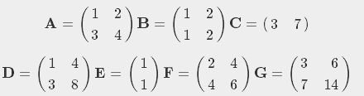
Þá er A+B=
- óskilgreint
- F
- B
Svar: b

